Name: Aditya Werulkar
PRN: 202501110208

EDS Lab Assignments

Practical 4

    - Pandas – Series Creation and Manipulation

Problem Statement:
Write a Python program that takes a list of numbers from the user, creates a Pandas series from it, and then calculates the mean of even and odd numbers separately using the groupby and mean() operations.
Hint: You can group the Series based on whether each number is even or odd.

Input Format:
- The user should enter a list of numbers separated by space when prompted.

Output Format:
- The program should display the mean of even and odd numbers separately.
- Each mean value should be displayed with a label indicating whether it corresponds to even or odd numbers.

Code:
import pandas as pd

# Take inputs from the user to create a list of numbers numbers = list(map(int, input().split()))

# Create a Pandas series from the list of numbers series = pd.Series(numbers)

# Grouping by even and odd numbers and calculating the mean grouped = series.groupby(series % 2 == 0).mean()

# Display the mean of even and odd numbers with labels
grouped.index = ['Even' if is_even else 'Odd' for is_even in grouped.index] print("Mean of even and odd numbers:")
print(grouped)

Output:

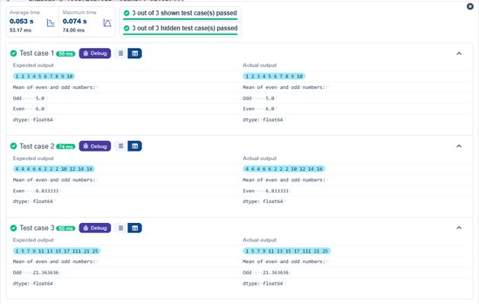

Dictionary to Dataframe

Problem Statement:
A dictionary of lists has been provided to you in the editor. Create a DataFrame from the dictionary of lists and perform the listed operations, then display the DataFrame before and after each manipulation.

Create the DataFrame:
- Convert the dictionary to a Pandas DataFrame.

Add a new row:
- Take inputs from the user for the new row data (name, age).
- Add the new row to the DataFrame.
- Display the DataFrame after adding the new row

Modify a row:
- Modify a specific row by changing the age. Take the row index and new age value from the user.
- Display the DataFrame after modifying the row

Delete a row:
- Take the row index to be deleted from the user.
- Remove the specified row.
- Display the DataFrame after deleting the row

Add a new column:
- Add a column Gender with values taken from the user.
- Display the DataFrame after adding the new column

Modify a column:
- Convert names to uppercase.
- Display the DataFrame after modifying the column.

Delete a column:
- Remove the Age column.

- Display the DataFrame after deleting the column.

Code:
import pandas as pd

# Provided dictionary of lists data = {
'Name': ['Alice', 'Bob', 'Charlie'], 'Age': [25, 30, 35],
}

# Convert the dictionary to a DataFrame df = pd.DataFrame(data)

# Display the original DataFrame print("Original DataFrame:") print(df)

# Adding a new
Name = input("New name: ") Age = int(input("New age: "))
new = {'Name':Name, 'Age':Age} df.loc[len(df)] = new
# Display the DataFrame after adding a new row print("After adding a row:\n",df)

# Modifying a row
index = int(input("Index of row to modify: ")) age = int(input("New age: "))
df.at[index, 'Age']=age

# Display the DataFrame after modifying a row print("After modifying a row:")
print(df)

# Deleting a row
delt = int(input("Index of row to delete: ")) df = df.drop(delt).reset_index(drop=True)
# Display the DataFrame after deleting a row print("After deleting a row:")
print(df)

# Adding a new column
gen = input("Enter genders separated by space: ").split() df['Gender']=gen
# Display the DataFrame after adding a new column print("After adding a new column:")
print(df)

# Modifying a column
df['Name']=df['Name'].str.upper()
# Display the DataFrame after modifying a column print("After modifying a column:")
print(df)

# Deleting a column
df = df.drop(columns = ['Age'])\
# Display the DataFrame after deleting a column print("After deleting a column:")
print(df)

Output:

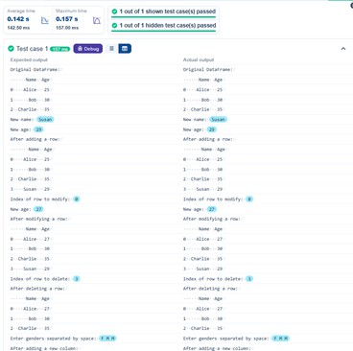

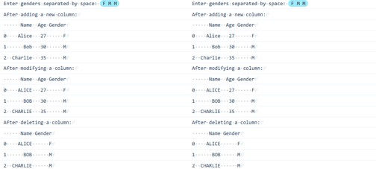

Student Information

Problem Statement:
Write a program to read a text file containing student information (name, age, and grade) using Pandas. Perform the following tasks:
      - Display the first five rows of the data frame.
      - Calculate the average age of the students (limit the average age up to 2 decimal places).
      - Filter out the students who have a grade above a certain threshold (consider the threshold grade is 'B').

Code:
import pandas as pd
# Read the text file into a DataFrame file = input()
data = pd.read_csv(file, sep="\s+", header=None, names=["Name", "Age", "Grade"]) # write your code here..
print("First five rows:") print(data.head()
average_age = round(data["Age"].mean(), 2) print(f"Average age: {average_age}")
filtered_students = data[data["Grade"] <= "B"] print("Students with a grade up to B") print(filtered_students)

Output:

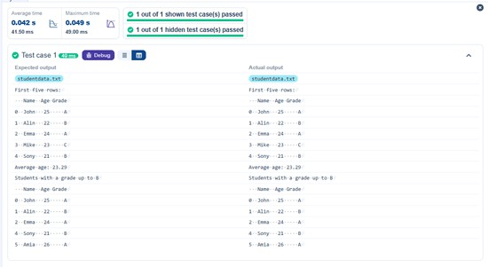

Month with the Highest Total Sales

Problem Statement:
Write a Python program that takes the file name of a CSV file as input, reads the data, and performs the following operations:
      - The CSV file contains the columns: Date, Product, Ǫuantity, Price, and City.
      - Group the data by Month and calculate the total sales for each month.
      - Find the month with the highest total sales and display it.
      - Also, display the total sales for the best month.

Code:
import pandas as pd
# Prompt the user for the file name file_name = input()
# Load the data
df = pd.read_csv(file_name)
df['Date'] = pd.to_datetime(df['Date'])
df['Total_Sales_Amount'] = df['Ǫuantity'] * df['Price']
Monthly_Sales = df.groupby(df['Date'].dt.strftime('%Y-%m'))['Total_Sales_Amount'].sum()

# Find the month with the highest total sales best_month = Monthly_Sales.idxmax()
highest_sales = Monthly_Sales.max() print(f"Best month: {best_month}") print(f"Total sales: ${highest_sales:.2f}")

Output:

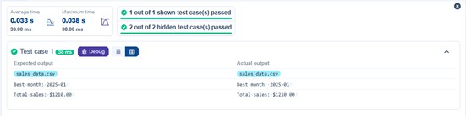

Best Selling Product

Problem Statement:
Write a Python program that takes the file name of a CSV file as input, reads the data, and performs the following operations:
      - The CSV file contains the columns: Date, Product, Ǫuantity, Price, and City.
      - Find the product that sold the most in terms of quantity sold.
      - Display the product that sold the most and the total quantity sold for that product.

Code:
import pandas as pd

# Prompt the user for the file name file_name = input()

# Load the data
df = pd.read_csv(file_name)
product_sales = df.groupby("Product")["Ǫuantity"].sum() # Find the product with the highest total quantity sold
best_product = product_sales.idxmax() highest_quantity = product_sales.max() # Display the result
print(f"Best selling product: {best_product}") print(f"Total quantity sold: {highest_quantity}")

Output:

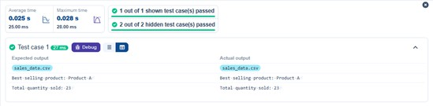

City that Sold the Most Products

Problem Statement:
Write a Python program that takes the file name of a CSV file as input, reads the data, and performs the following operations:
      - The CSV file contains the columns: Date, Product, Ǫuantity, Price, and City.
      - Group the data by City and calculate the total quantity of products sold for each city.
      - Find the city that sold the most products (based on the total quantity sold).

Code:
import pandas as pd

# Prompt the user for the file name file_name = input()
# Load the data
df = pd.read_csv(file_name) # write the code..
city_sales = df.groupby("City")["Ǫuantity"].sum( best_city = city_sales.idxmax()

# Display the result
print(f"City sold the most products: {best_city}")

Output:

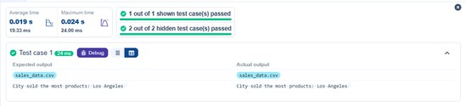

Most Frequently Sold Product Pairs

Problem Statement:

Write a Python program that takes the file name of a CSV file as input, reads the data, and performs the following operations:
      - The CSV file contains the following columns: Date, Product, Ǫuantity, Price, and City.
      - For each date, find all pairs of products that were sold together (i.e., two products sold on the same date).
      - Output the product pair/s that was sold most frequently.

Code:
import pandas as pd

from itertools import combinations from collections import Counter

# Prompt user to input the file name file_name = input()

# Read data from the specified CSV file df = pd.read_csv(file_name)

# write the code
grouped = df.groupby("Date")["Product"].apply(list)

pairs_counter = Counter() for products in grouped:
pairs = combinations(sorted(products), 2) pairs_counter.update(pairs)

max_frequency = max(pairs_counter.values())
most_common_pairs = [(pair, freq) for pair, freq in pairs_counter.items() if freq == max_frequency]

# Output the most frequent product pairs
for(product1, product2), frequency in most_common_pairs:

print(f"{product1} and {product2}: {frequency} times")

Output:

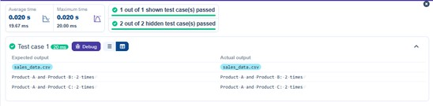

Titanic Dataset Analysis and Data Cleaning

Problem Statement:
You are provided with the Titanic dataset containing information about passengers on the Titanic. Your task is to write Python code to answer the following questions based on the dataset. For each question, perform necessary data cleaning, transformations, and calculations as required.
- Display the first 5 rows of the dataset.
- Display the last 5 rows of the dataset.
- Get the shape of the dataset (number of rows and columns).
- Get a summary of the dataset (using .info()).
- Get basic statistics (mean, standard deviation, etc.) of the dataset using .describe().
- Check for missing values and display the count of missing values for each column.
- Fill missing values in the ‘Age’ column with the median age.
- Fill missing values in the ‘Embarked’ column with the most frequent value (mode()).
- Drop the ‘Cabin’ column due to many missing values.
- Create a new column, 'FamilySize' by adding the 'SibSp' and 'Parch' columns.

Code:
import pandas as pd import numpy as np

# Load the Titanic dataset
data = pd.read_csv('Titanic-Dataset.csv') print(data.head())

# 1. Display the first 5 rows of the datase print(data.tail())

# 2. Display the last 5 rows of the dataset print(data.shape)

# 3. Get the shape of the dataset print(data.info())

# 4. Get a summary of the dataset (info) print(data.describe())

# 5. Get basic statistics of the dataset print(data.isnull().sum())

# 6. Check for missing value median_age = data['Age'].median()
data['Age'].fillna(median_age, inplace = True)

# 7. Fill missing values in the ‘Age’ column with the median age mode_embarked = data['Embarked'].mode() [0]
data['Embarked'].fillna(mode_embarked, inplace = True)

# 8. Fill missing values in the ‘Embarked’ column with the mode data.drop('Cabin', axis=1, inplace = True)

# 9. Drop the ‘Cabin’ column due to many missing values data['FamilySize'] = data['SibSp'] + data['Parch']
# 10. Create a new column 'FamilySize’ by adding ‘SibSp' and ‘Parch'

Output:

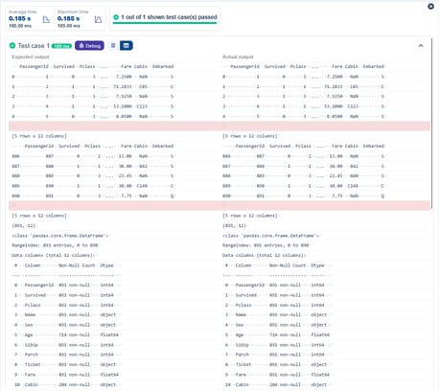

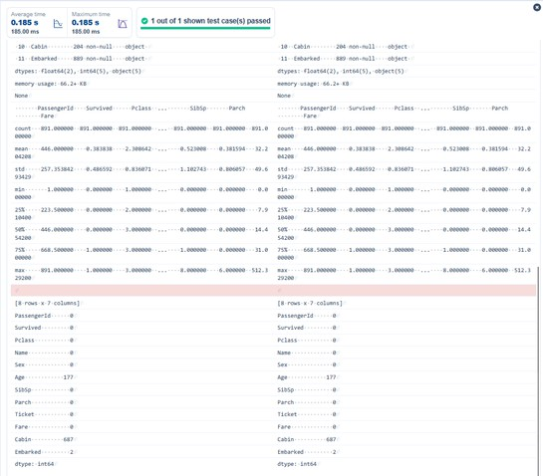

Titanic Dataset Analysis and Data Cleaning-2

Problem Statement:
You are provided with the Titanic dataset containing information about passengers on the Titanic. Your task is to write Python code to answer the following questions based on the dataset.
- Create a new column ‘IsAlone’ which is 1 if the passenger is alone (FamilySize = 0), otherwise 0.
- Convert the ‘Sex' column to numeric values (male: 0, female: 1).
- One-hot encode the ‘Embarked’ column, dropping the first category.
- Get the mean age of passengers.
- Get the median fare of passengers.
- Get the number of passengers by class.
- Get the number of passengers by gender.
- Get the number of passengers by survival status.
- Calculate the survival rate of passengers.
- Calculate the survival rate by gender.

Code:
import pandas as pd import numpy as np

# Load the Titanic dataset
data = pd.read_csv('Titanic-Dataset.csv') data['FamilySize'] = data['SibSp'] + data['Parch']

# 1. Create a new column ‘IsAlone' (1 if alone, 0 otherwise) data['Alone'] = np.where(data['FamilySize'] == 0, 1, 0)

# 2. Convert ‘Sex' to numeric (male: 0, female: 1) data['Sex'] = data['Sex'].map({'male': 0, 'female': 1})

# 3. One-hot encode the ‘Embarked' column
data = pd.get_dummies(data, columns = ['Embarked'], drop_first = True)

# 4. Get the mean age of passengers mean_age = data['Age'].mean()

print(mean_age)

# 5. Get the median fare of passengers median_fare = data['Fare'].median() print(median_fare)

# 6. Get the number of passengers by class passengers_by_class = data['Pclass'].value_counts() print(passengers_by_class)

# 7. Get the number of passengers by gender
passengers_by_gender = data['Sex'].value_counts().sort_index() print(passengers_by_gender)

# 8. Get the number of passengers by survival status
passengers_by_survival = data['Survived'].value_counts().sort_index() print(passengers_by_survival)

# 9. Calculate the survival rate
survival_rate = data['Survived'].mean() print(survival_rate)

# 10. Calculate the survival rate by gender
survival_rate_by_gender = data.groupby('Sex')['Survived'].mean() print(survival_rate_by_gender)

Output:

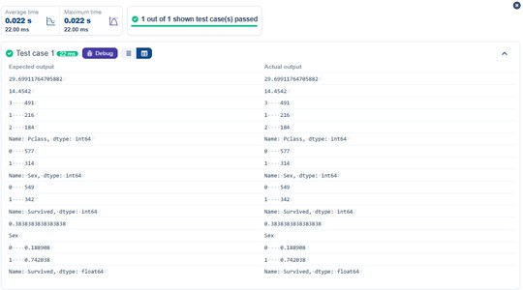

Titanic Dataset Analysis and Data Cleaning-3

Problem Statement:
You are provided with the Titanic dataset containing information about passengers on the Titanic. Your task is to write Python code to answer the following questions based on the dataset.
- Calculate the survival rate by class.
- Calculate the survival rate by embarkation location (Embarked_S).
- Calculate the survival rate by family size (FamilySize).
- Calculate the survival rate by being alone (IsAlone).
- Get the average fare by passenger class (Pclass).
- Get the average age by passenger class (Pclass).
- Get the average age by survival status (Survived).
- Get the average fare by survival status (Survived).
- Get the number of survivors by class (Pclass).
- Get the number of non-survivors by class (Pclass).

Code:
import pandas as pd import numpy as np
# Load the Titanic dataset
data = pd.read_csv('Titanic-Dataset.csv')

data['FamilySize'] = data['SibSp'] + data['Parch']
data['IsAlone'] = np.where(data['FamilySize'] > 0, 0, 1)
data = pd.get_dummies(data, columns=['Embarked'], drop_first=True)

# 1. Calculate the survival rate by class print(data.groupby('Pclass')['Survived'].mean()
# 2. Calculate the survival rate by embarked location print(data.groupby('Embarked_S')['Survived'].mean()) # 3. Calculate the survival rate by family size print(data.groupby('FamilySize')['Survived'].mean()) # 4. Calculate the survival rate by being alone print(data.groupby('IsAlone')['Survived'].mean()
# 5. Get the average fare by class print(data.groupby('Pclass')['Fare'].mean()) # 6. Get the average age by class print(data.groupby('Pclass')['Age'].mean()) # 7. Get the average age by survival status
print(data.groupby('Survived')['Age'].mean()) # 8. Get the average fare by survival status print(data.groupby('Survived')['Fare'].mean()) # 9. Get the number of survivors by class
print(data[data['Survived'] == 1]['Pclass'].value_counts()) # 10. Get the number of non-survivors by class print(data[data['Survived'] == 0]['Pclass'].value_counts())

Output:

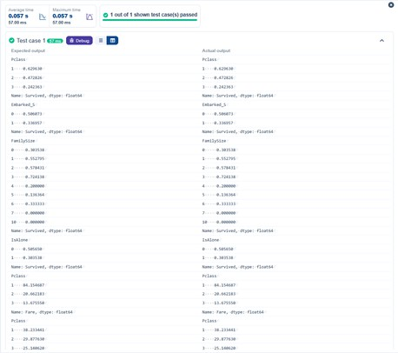

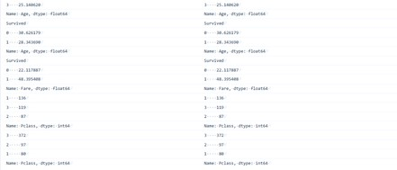

Titanic Dataset Analysis and Data Cleaning-4

Problem Statement:

You are provided with the Titanic dataset containing information about passengers on the Titanic. Your task is to write Python code to answer the following questions based on the dataset.
- Get the number of survivors by gender (Sex).
- Get the number of non-survivors by gender (Sex).
- Get the number of survivors by embarkation location (Embarked_S).
- Get the number of non-survivors by embarkation location (Embarked_S).
- Calculate the percentage of children (Age < 18) who survived.
- Calculate the percentage of adults (Age >= 18) who survived.
- Get the median age of survivors.
- Get the median age of non-survivors.
- Get the median fare of survivors.
- Get the median fare of non-survivors.

Code:
import pandas as pd import numpy as np

# Load the Titanic dataset
data = pd.read_csv('Titanic-Dataset.csv')
data = pd.get_dummies(data, columns=['Embarked'], drop_first=True)

# 1. Get the number of survivors by gender
survivors_by_gender = data[data['Survived'] == 1]['Sex'].value_counts() print(survivors_by_gender)

# 2. Get the number of non-survivors by gender
non_survivors_by_gender = data[data['Survived'] == 0]['Sex'].value_counts() print(non_survivors_by_gender)

# 3. Get the number of survivors by embarked location
survivors_by_embarked_s = data[data['Survived'] == 1]['Embarked_S'].value_counts() print(survivors_by_embarked_s)

# 4. Get the number of non-survivors by embarked location

non_survivors_by_embarked_s = data[data['Survived'] == 0]['Embarked_S'].value_counts() print(non_survivors_by_embarked_s)

# 5. Calculate the percentage of children (Age < 18) who survived children = data[data['Age'] < 18]
children_survival_rate = children['Survived'].mean() print(children_survival_rate)

# 6. Calculate the percentage of adults (Age >= 18) who survived adults = data[data['Age'] >= 18]
adults_survival_rate = adults['Survived'].mean() print(adults_survival_rate)

# 7. Get the median age of survivors
median_age_survivors = data[data['Survived'] == 1]['Age'].median() print(median_age_survivors)

# 8. Get the median age of non-survivors
median_age_non_survivors = data[data['Survived'] == 0]['Age'].median() print(median_age_non_survivors)

# 9. Get the median fare of survivors
median_fare_survivors = data[data['Survived'] == 1]['Fare'].median() print(median_fare_survivors)

# 10. Get the median fare of non-survivors
median_fare_non_survivors = data[data['Survived'] == 0]['Fare'].median() print(median_fare_non_survivors)

Output:

